Bhanu Prakash Reddy Chilukuri

nb healthcare technologies

09-02-2022

Day13 assignments

|  |
| --- |
| 1. Declare a 2-dimensional array of size (2,2) and initialize using indexes and print the values using nested for loop. |

Code:

//Author: Bhanu Prakash Reddy

//WACP for 2D Array of size (2,2) using nested for loop

internal class Program

{

static void Main(string[] args)

{

int[,] data = new int[,]

{

{5,8},

{16,14}

};

//nested for loop

for (int i = 0; i < 2; i++)

{

for(int j = 0; j < 2; j++)

{

Console.Write(data[i,j] + " ");

}

Console.WriteLine();

}

Console.ReadLine();

}

}

Output:

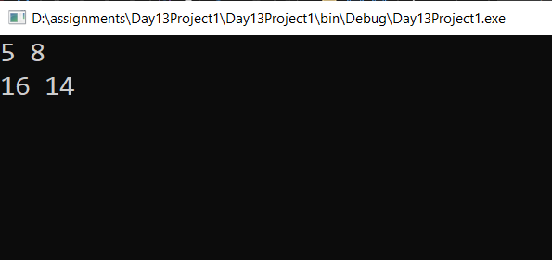

|  |
| --- |
| 2. Declare a 2-D array of size (3,2) and initialize in the same line while declaring and print the values using nested for loop. |

Code:

//Author: Bhanu Prakash Reddy

//WACP for 2D array of size (3,2) and initialize in same line and print using nested for loop

internal class Program

{

static void Main(string[] args)

{

int[,] data = { { 4, 8 }, { 12, 18 }, { 22, 36 } };

//Nested for loop

for(int i = 0;i<data.GetLength(0);i++)

{

for (int j=0;j<data.GetLength(1);j++)

{

Console.Write(data[i,j]+" ");

}

Console.Write("\n");

}

Console.ReadLine();

}

}

Output:

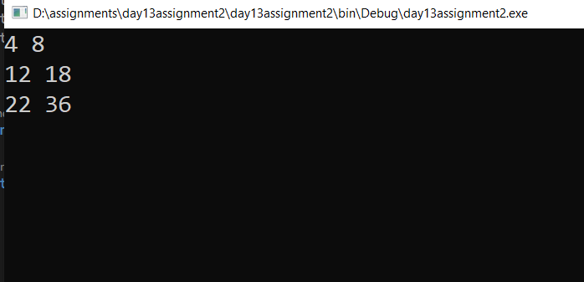

|  |
| --- |
| 3. Declare a 2-D array of size (3,3) and print trace of the array. |

Code:

//Author: Bhanu Prakash Reddy

// WACP for finding the trace of the array of size (3,3)

internal class Program

{

static void Main(string[] args)

{

int[,] data = { { 4, 8, 9 }, { 15, 23, 67 }, { 14, 32, 18 } };

int sum = 0;

for (int i = 0; i < data.GetLength(0); i++)

{

for (int j = 0; j < data.GetLength(1); j++)

//Trace of the Matrix

{

if (i == j)

sum += data[i, j];

}

}

Console.WriteLine($"Trace of the matrix is {sum}");

Console.ReadLine();

}

}

Output:

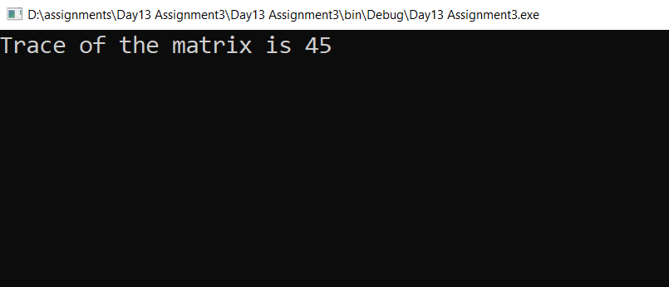

|  |
| --- |
| 4. Declare a 2-D array of size (2,2) and read values from user and print the array values. |

Code:

// Author: Bhanu Prakash Reddy

//WACP 2D array of size (2,2) and read values from user and print values

internal class Program

{

static void Main(string[] args)

{

int[,] data = new int[2, 2];

//Read Values from user

for(int i=0; i<data.GetLength(0); i++)

{

for(int j=0; j<data.GetLength(1); j++)

{

Console.WriteLine($"Enter the value at ({i},{j}) : ");

data[i,j] = Convert.ToInt32(Console.ReadLine());

}

}

//Print values

for (int i = 0; i < data.GetLength(0); i++)

{

for (int j = 0; j < data.GetLength(1); j++)

{

Console.Write(data[i,j]+" ");

}

Console.Write("\n");

}

Console.ReadLine();

}

}

Output:

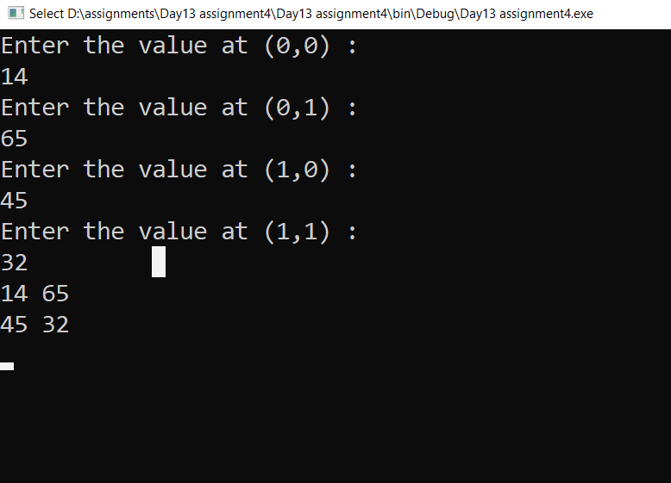

|  |
| --- |
| 5. Declare TWO 2-D arrays of size (2,2) and read values from user and print the sum of the two matrices. |

Code:

//Author : Bhanu Prakash Reddy

//WACP sum of the matrices

internal class Program

{

static void Main(string[] args)

{

int[,] data1 = new int[2, 2];

int[,] data2 = new int[2, 2];

int[,] data3 = new int[2, 2];

//Read Values from user

for (int i = 0; i < data1.GetLength(0); i++)

{

for (int j = 0; j < data1.GetLength(1); j++)

{

Console.WriteLine($"Enter the value at ({i},{j}) : ");

data1[i, j] = Convert.ToInt32(Console.ReadLine());

}

}

//print data1 array

for (int i = 0; i < data1.GetLength(0); i++)

{

for (int j = 0; j < data1.GetLength(1); j++)

{

Console.Write(data1[i, j] + " ");

}

Console.Write("\n");

}

//read value from user

for (int i = 0; i < data2.GetLength(0); i++)

{

for (int j = 0; j < data2.GetLength(1); j++)

{

Console.WriteLine($"Enter the value at ({i},{j}) : ");

data2[i, j] = Convert.ToInt32(Console.ReadLine());

}

}

//print data2 array

for (int i = 0; i < data2.GetLength(0); i++)

{

for (int j = 0; j < data2.GetLength(1); j++)

{

Console.Write(data2[i, j] + " ");

}

Console.Write("\n");

}

//sum of the two matrices

for (int i = 0; i < data3.GetLength(0); i++)

{

for (int j = 0; j < data3.GetLength(1); j++)

{

int sum = data1[i,j] + data2[i,j];

data3[i,j] = sum;

}

}

Console.WriteLine($"Sum of tho Matrices :");

for (int i = 0; i < data3.GetLength(0); i++)

{

for (int j = 0; j < data3.GetLength(1); j++)

{

Console.Write($"{data3[i, j]} ");

}

Console.Write("\n");

}

Console.ReadLine();

}

}

Output:

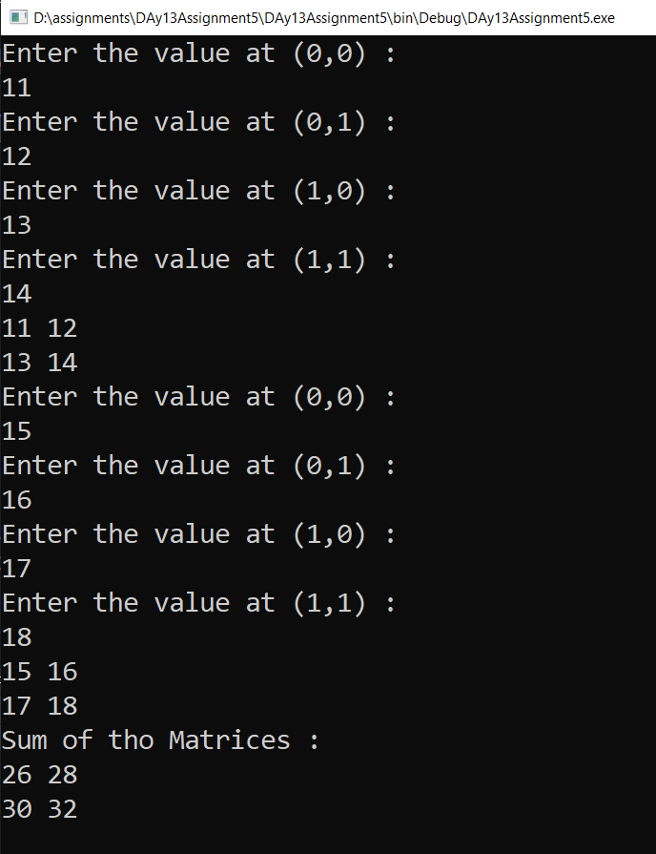

|  |
| --- |
| 5. Declare TWO 2-D arrays of size (2,2) and read values from user and print the sum of the two matrices. |

Code:

//Author: Bhanu Prakash Reddy

// WACP for the product of two matrices

internal class Program

{

static void Main(string[] args)

{

int fm1, fm2, sm1, sm2;

//Read Data

Console.WriteLine("Enter Row size of First Matrix: ");

fm1 = Convert.ToInt32(Console.ReadLine());

Console.WriteLine("Enter colomn size of First Matrix: ");

fm2 = Convert.ToInt32(Console.ReadLine());

Console.WriteLine("Enter Row size of Second Matrix: ");

sm1 = Convert.ToInt32(Console.ReadLine());

Console.WriteLine("Enter colomn size of Second Matrix: ");

sm2 = Convert.ToInt32(Console.ReadLine());

int[,] firstmatrix = new int[fm1, fm2];

int[,] secondmatrix = new int[sm1, sm2];

int[,] productmatrix = new int[fm1, sm2];

//first matrix

for(int i = 0;i<fm1;i++)

{

for(int j = 0;j<fm2;j++)

{

Console.Write($"Enter number at ({i},{j}): ");

firstmatrix[i,j] = Convert.ToInt32(Console.ReadLine());

}

}

for (int i = 0; i<fm1;i++)

{

for(int j =0;j<fm2;j++)

{

Console.Write($"{firstmatrix[i, j]} ");

}

Console.Write("\n");

}

//second matrix

for (int i = 0; i < sm1; i++)

{

for (int j = 0; j < sm2; j++)

{

Console.Write($"Enter number at ({i},{j}): ");

secondmatrix[i,j]= Convert.ToInt32(Console.ReadLine());

}

}

for (int i=0;i<sm1;i++)

{

for(int j=0;j<sm2;j++)

{

Console.Write($"{secondmatrix[i, j]} ");

}

Console.Write("\n");

}

//product matrix

if(fm2 != sm1)

{

Console.WriteLine("Product of Matrix is not possible");

}

else

{

for (int i = 0; i < fm1; i++)

{

for (int j = 0; j < sm2; j++)

{

productmatrix[i, j] = 0;

for(int k= 0; k < fm2; k++)

{

productmatrix[i, j] += firstmatrix[i, k] * secondmatrix[k, j];

}

}

}

Console.WriteLine("Product of the two matrix: ");

for(int i=0;i<fm1;i++)

{

for(int j=0;j<sm2;j++)

{

Console.Write($"{productmatrix[i, j]} ");

}

Console.Write("\n");

}

Console.ReadLine();

}

}

}

Output:

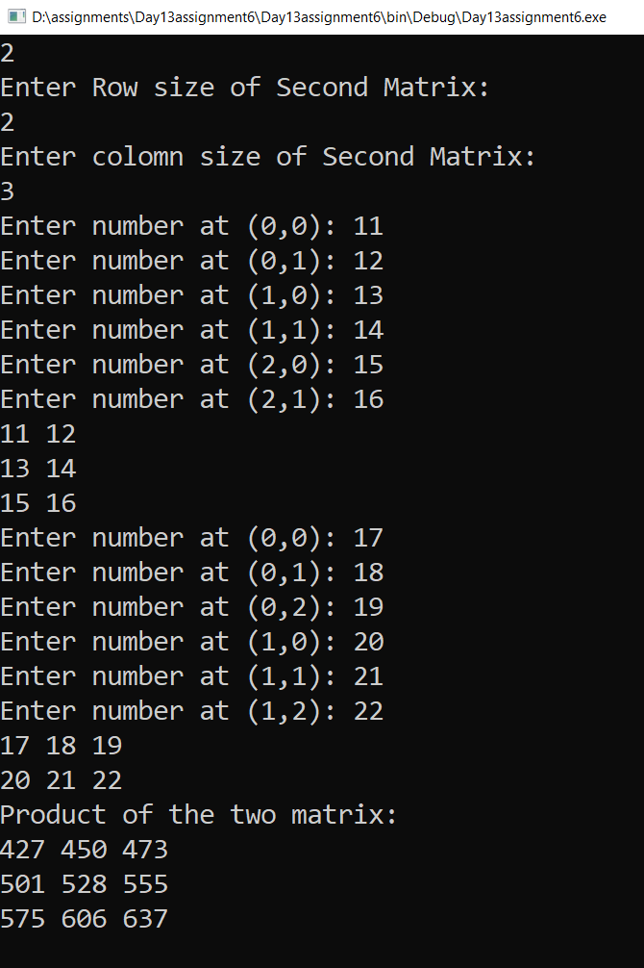

|  |
| --- |
| 7. What is a jagged array.  What is the benefit of jagged array? |

* A Jagged array is a 2D-Array saving different sizes.
* A jagged array is an array whose elements are arrays.
* A jagged array sometimes calls as array of arrays.
* Jagged array saves memory.

|  |
| --- |
| 8. WACP to declare a jagged array and print values. |

Code:

//Author: Bhanu Prakash Reddy

//WACP for jagged array

internal class Program

{

static void Main(string[] args)

{

char[][] names = new char[3][];

names[0] = new char[] { 'K', 'O', 'B', 'E' };

names[1] = new char[] { 'L', 'E', 'B', 'R', 'O', 'N' };

names[2] = new char[] { 'J', 'O', 'R', 'D', 'O', 'N' };

//Array elements

for (int i = 0;i<names.Length;i++)

{

Console.Write($"Name at position {i} : ");

for(int j=0;j<names[i].Length;j++)

{

Console.Write(names[i][j]);

}

Console.Write("\n");

}

Console.ReadLine();

}

}

Output:

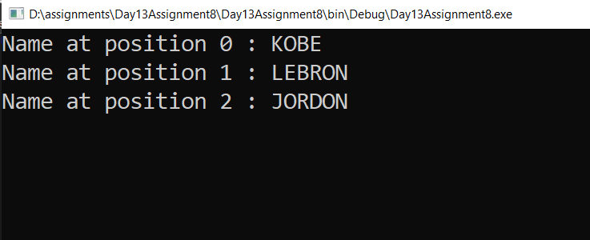

|  |
| --- |
| 9. What is Recursion. |

* A function calling itself repeatedly until a specified condition is satisfied.
* This will call function with parameters and receive new parameter after every execution.

|  |
| --- |
| 10. WACP to illustrate usage of Recursion. |

Code:

//Authir: Bhanu Prakash Reddy

//WACP for Recursion

internal class Program

{

class Factorial

{

public int Fact(int number)

{

if (number == 1)

return 1;

else

return number * Fact(number - 1);

}

}

static void Main(string[] args)

{

int input;

Console.Write("Enter number : ");

input = Convert.ToInt32(Console.ReadLine());

Factorial fact =new Factorial();

Console.WriteLine($"Factorial is {fact.Fact(input)}");

Console.ReadLine();

}

}

Output:

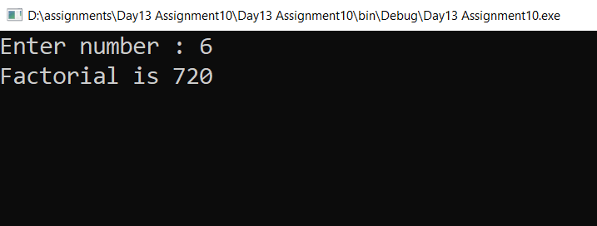

|  |
| --- |
| 11. WACP to illustrate usage of Stack<>  Write couple of points about Stack. |

* Stack is a special type of collection that stores elements in LIFO style => Last In First Out.
* POP – Removes the elements and return the elements.
* PEEK – Not remove the elements and return the elements.

Code:

//Authir: Bhanu Prakash Reddy

//WACP for Recursion

internal class Program

{

class Factorial

{

public int Fact(int number)

{

if (number == 1)

return 1;

else

return number * Fact(number - 1);

}

}

static void Main(string[] args)

{

int input;

Console.Write("Enter number : ");

input = Convert.ToInt32(Console.ReadLine());

Factorial fact =new Factorial();

Console.WriteLine($"Factorial is {fact.Fact(input)}");

Console.ReadLine();

}

}

Output:



|  |
| --- |
| 11. WACP to illustrate usage of Queue<>  Write couple of points about Queue. |

* Queue represents a first-in, first-out collection of objects.
* It is used when you need a first-in, first-out access of items.

Code:

//Author: Bhanu Prakash Reddy

//WACP for Stack

internal class Program

{

static void Main(string[] args)

{

Stack<int> data = new Stack<int>();

data.Push(11);

data.Push(12);

data.Push(13);

for (int i = 0; i <= data.Count; i++)

Console.WriteLine($"Element POP {data.Pop()}");

Console.WriteLine($"Element peek {data.Peek()}");

Console.ReadLine();

}

}

Output:

